Colonial Villa |  |  | 10:00a Coffee & Cookies (A)  1:00p Catholic Service (A)  2:00p Exercise (A)  3:00p Skip Bo (A)  (Card Game) | Happy Birthday Elaine W.  10:00a Exercise (A)  1:30p Fancy Fingers (A)  (Manicures)  3:00p 500 Rummy Card (A)  4:30p Happy Hour (D)  w/ Don C. | 12:00p Popcorn (D)  2:00p Exercise (A)  3:00p Bingo (A) | Jigsaw Puzzles, Games, and  Cards on the Mezzanine  (2nd Floor)  Or  Billiards (3rd Floor)
Happy Birthday Ron H.  Jigsaw Puzzles, Games, and  Cards on the Mezzanine  (2nd Floor)  Or  Billiards (3rd Floor) | Resident Shopping  10:00a Exercise (A)  1:00p Church Service (A)  1:45p Yahtzee (A)  3:00p Euchre (A) | 12:00p Piano Music (D)  w/ Mary Edwards  2:00p Exercise (D)  3:00p Bingo (A) | Happy Birthday Beverly M.  10:00a Coffee & Donuts (A)  1:00p Catholic Service (A)  2:00p Exercise (A)  3:00p Race Against Time  Game (A) | 10:00a Exercise (A)  1:30p Fancy Fingers (A)  (Manicures)  3:00p Christmas Craft (A)  (w/ Kelly) | 10:00a Exercise (A)  1:30p Bingo (A)  4:00p Resident Christmas Party (D) | Happy Birthday Angie G.  Jigsaw Puzzles, Games, and  Cards on the Mezzanine  (2nd Floor)  Or  Billiards (3rd Floor)
Jigsaw Puzzles, Games, and  Cards on the Mezzanine  (2nd Floor)  Or  Billiards (3rd Floor) | Resident Shopping  10:00a Exercise (A)  1:00p Church Service (A)  1:45p Yahtzee (A)  3:00p Euchre (A) | 8:30a Veterans Breakfast (A)  12:00p Piano Music (D)  w/ Mary Edwards  2:00p Exercise (A)  3:00p Bingo (A) | 1:00p Catholic Service (C)  1:30p Staff Christmas Party  (A) | 10:00a Exercise (A)  1:30p Fancy Fingers (A)  (Manicures)  3:00p Christmas Craft (A)  4:30p Happy Hour (D)  w/ Amanda Kari | 11:00p Lunch Outing (*)  2:00p Exercise (A)  3:00p Bingo (A) | Jigsaw Puzzles, Games, and  Cards on the Mezzanine  (2nd Floor)  Or  Billiards (3rd Floor)
Jigsaw Puzzles, Games, and  Cards on the Mezzanine  (2nd Floor)  Or  Billiards (3rd Floor) | Resident Shopping  10:00a Exercise (A)  1:00p Church Service (A)  1:45p Yahtzee (A)  3:00p Euchre (A) | 12:00p Piano Music (D)  w/ Mary Edwards  2:00p Exercise (D)  3:00p Bingo (A) | 10:00a Coffee & Donuts (A)  1:00p Catholic Service (A)  2:00p Exercise (A)  3:00p 10,000 Dice Game (A) | 10:00a Exercise (A)  1:30p Fancy Fingers (A)  (Manicures)  3:00p Race Against Time  Game (A) | 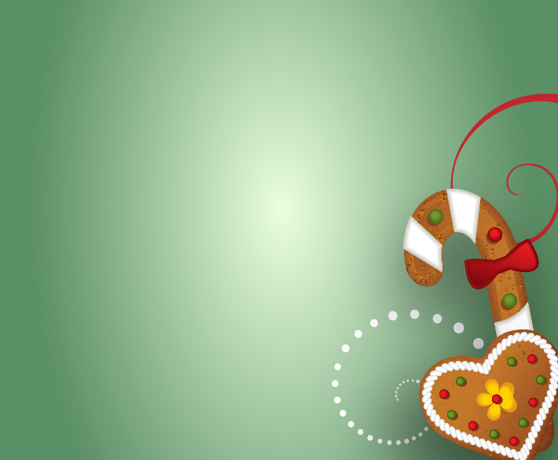  Happy Birthday Garry C.  10:00a Exercise (A)  1:30p Bingo (A) | Merry Christmas
Jigsaw Puzzles, Games, and  Cards on the Mezzanine  (2nd Floor)  Or  Billiards (3rd Floor) | Resident Shopping  10:00a Exercise (A)  1:00p Church Service (A)  1:45p Yahtzee (A)  3:00p Euchre (A) | 12:00p Piano Music (D)  w/ Mary Edwards  2:00p Exercise (D)  3:00p Bingo (A) | 10:00a Coffee & Cookies (A)  1:00p Catholic Service (A)  2:00p Exercise (A)  3:00p Target Practice (A) | 10:00a Exercise (A)  1:30p Fancy Fingers (A)  (Manicures)  3:00p 10,000 Dice Game (A) | 11:00a New Year’s Eve Party  w/ Frank Sinatra Impersonator) (D)
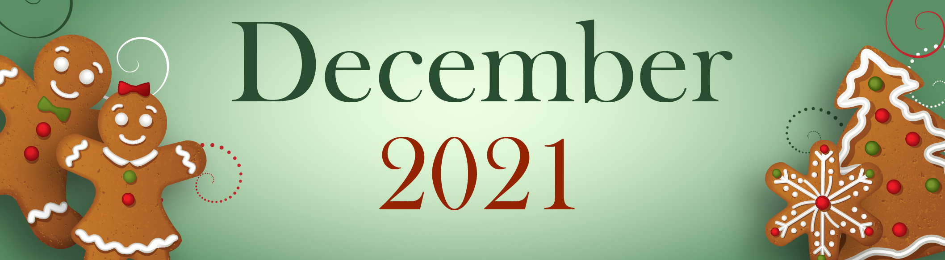
Activities are subject to change. (A) = Activity Room – (C) = Chapel - (D) = Dining Room – (O) = Outing - (*) = Sign-Up with Kelly for that event.
Sunday | Monday | Tuesday | Wednesday | Thursday | Friday | Saturday
 |  |  | 1 | 2 | 3 | 4
5 | 6 | 7 | 8 | 9 | 10 | 11
12 | 13 | 14 | 15 | 16 | 17 | 18
19 | 20 | 21  Winter Begins | 22 | 23 | 24 | 25  Christmas
26  Kwanzaa Begins | 27 | 28 | 29 | 30 | 31  New Year’s Eve

